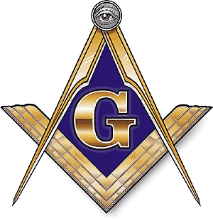
PLAYER REGISTRATION FORM
FERNLEY MASON LODGE #34 F&AM
GOLF TOURNAMENT
SEPTEMBER 7, 2023 (Saturday) GOLF CLUB OF FERNLEY
Please come be a part of our annual fundraiser to help our local kids. Money raised will be used to create scholarships for high school students in or area, to help support the Fernley High School Band, and to support the Shriner Hospital that serves our needy children.
You can help expand the opportunities our kids need to succeed.

The $80.00 Entry Fee per player includes green fees (portion is waved if already Fernley Golf Club member), cart per pair, and goodie bag. No outside beverages will be permitted.

Shotgun Start at 10:00 A.M, 4-man best ball scramble. The purchase of mulligans, stretch tape and raffle tickets available at check in. Golfers must comply with course dress code (no denim).

Payment must be received by August 16, 2024 and is nonrefundable after that date.

GOLF CLUB OF FERNLEY located at 50 Desert Lakes Drive, Fernley, NV 89408

Thank you in advance and we hope you enjoy our event.
We greatly appreciate your continued support.

Player #1
Name:__________________________________________ Phone:____________

Email____________________ Address________________________________________

Player #2
Name:__________________________________________ Phone:____________

Email____________________ Address________________________________________

Player #3
Name:__________________________________________ Phone:____________

Email____________________ Address________________________________________

Player #4
Name:__________________________________________ Phone:____________

Email____________________ Address________________________________________

Contact: E-Mail Form to FernleyLodge34@outlook.com
Fernley Lodge #34, F. & A. M.
P. O. Box 297, Fernley, NV 89408
Visit website fernleylodge34.org,

